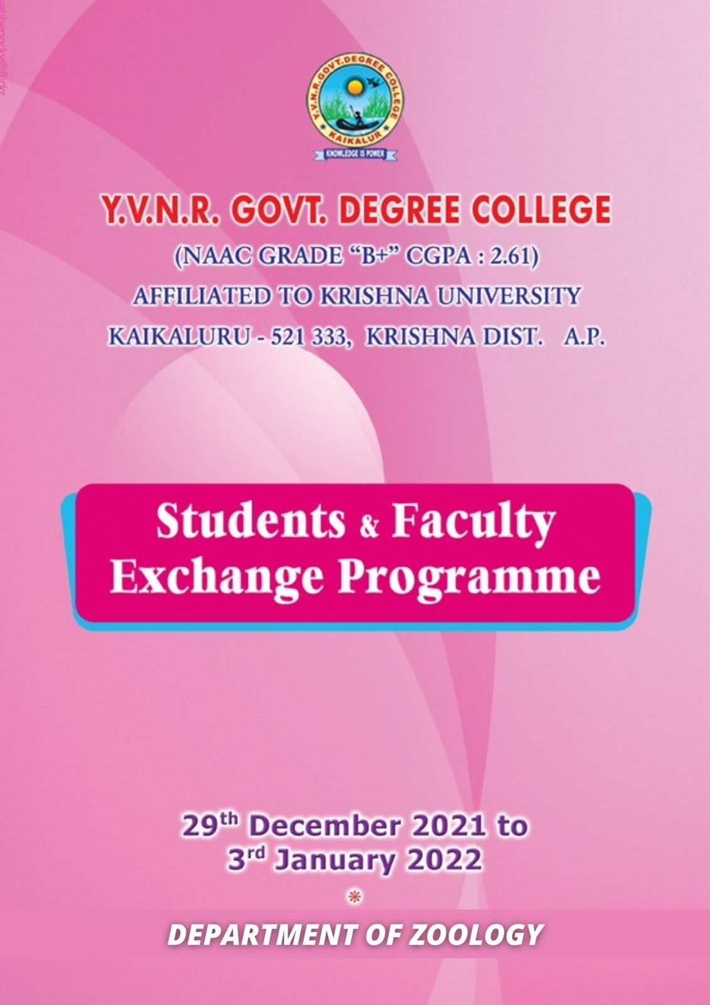

**STUDENT FACULTY EXCHANGE PROGRAM**

**The Student - Faculty Exchange Program is initiated to enhance students and faculty development through knowledge, experience and strategy sharing for the mutual benefit of teachers, students and institution. The open channel communication through the Program was to facilitate understanding and encourage both Institutional faculties to broaden experience and knowledge and to improve performance in teaching-learning process, research and administration.**

**Student Exchange Program is one of the unique activities recommended by University Grants Commission as part of reforms in Higher Education policy. In this program, the students studying in various programs in two or more colleges will be selectively swapped. The purpose of the activity is to enrich the academic excellence among higher educational institutions to benefit the student community by exposing them to diverse intellectual capabilities and competencies of faculty and also sharing of the infrastructure facilities in the process of learning. The following are the objectives of SEP.**

**Objectives**

**To expose the students to diversified intellectual capabilities of the faculty in various disciplines.**

**To facilitate qualitative teaching and learning for the development of the students.**

**To enable to students to gain diversified skills to enhance their knowledge in their domain areas.**

**To share the experience of gaining knowledge and skills among the peers.**

**To access various e-learning resources available in their respective colleges to improve their knowledge.**

**In this connection, the YVNR Government DEGREE College, KAIKALURU and SIR C R REDDY AUTONOMOUS COLLEGE, ELURU have mutually agreed upon to enter into a MoU to implement the program in their respective colleges.**

**Final year students of MPC and BZC programmes along with the following faculty participated for one week i.e., from 29TH DECEMBER TO 3RD JANUARY 2022.**

1. **Dr.K.A.Emmanuel, Lecturer in Chemistry**
2. **Dr.P.Paul Divakar, Lecturer in Physics**
3. **Dr.V.Sandhya, Lecturer in Zoology**
4. **Smt.Y.Gnana Prasunamba, Lecturer in Botany**

**The entire one week schedule was well formulated with activities related to practical work and facilitated an experiential learning about the research culture.**

**The group enrolled on a joyful journey of experiencing food and different colours of Eluru. This programme was a milestone in our personal and professional journey of knowing each other’s college and people. This report cannot be concluded without mentioning the unstinted support and involvement of Management Principal, Staff and students of Sir C R Reddy College for taking extra care about the delegation from Y.V.N.R. Government Degree College, Kaikaluru.**

**We wish relationship between Y.V.N.R. Government Degree College, Kaikaluru and Sir C R Reddy College to grow from strength to strength with each passing year.**

**This programme is conducted to fulfill 3.7.1 of NAAC guidelines. The outcome of exchange is targeted towards developing and enhancing the skills and knowledge content of faculty cross exchange of best practices and experiences**

**Signature of the Lecturer Signature of the H.O.D Signature of the Principal**

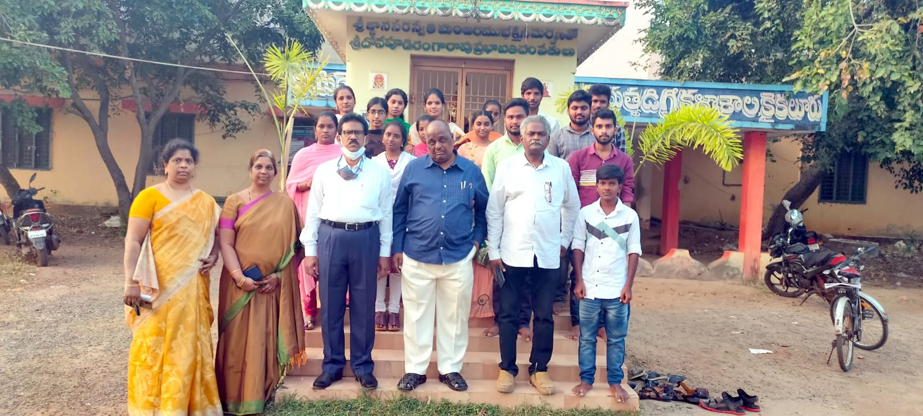

**At Y.V.N.R. Govt. Degree College, Kaikaluru, Krishna District**

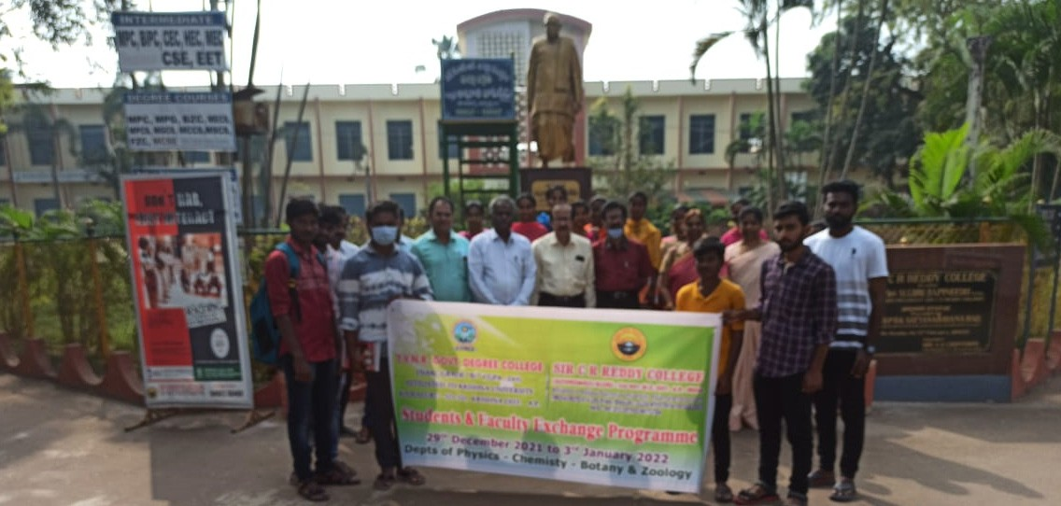

**Sir C. R. Reddy College, Eluru**

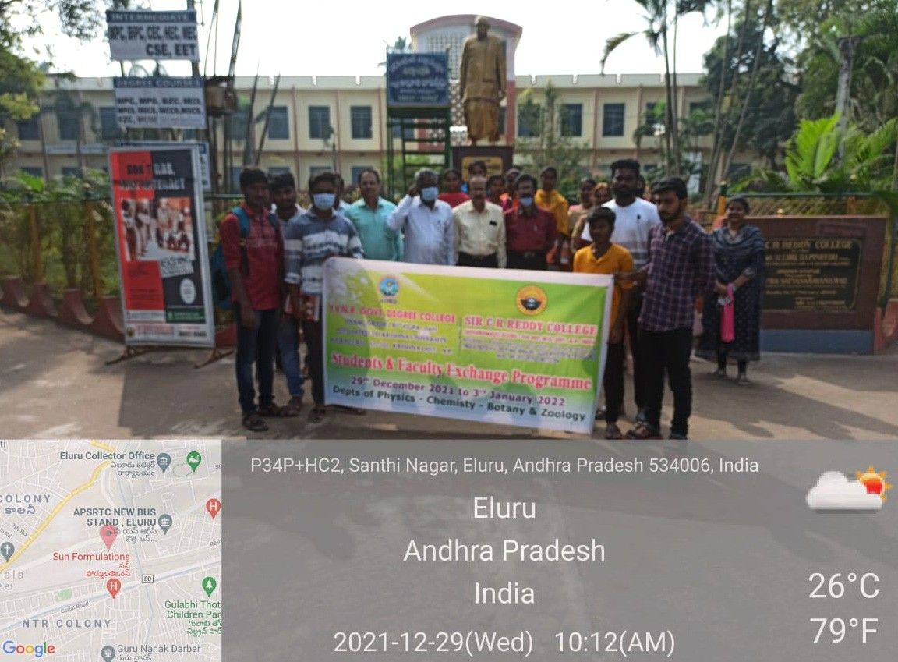

**Sir C. R. Reddy College, Eluru**

***STUDENTS & FACULTY EXCHANGE PROGRAMME***

# 29-12-2021 TO 03-01-2022.

Programme sheet

**INAUGURAL FUNCTION**

|  |  |  |  |
| --- | --- | --- | --- |
| **S.No.** | **Time** | **Programme** | **Name of the person** |
| 01 | 10.00-10.05 | Invitation of Guests on to the Dias | V. Vijay kumar |
| 02 | 10.05-10.10 | Prayer | Students |
| 03 | 10.10-10.15 | Opening Remarks By President. | Dr. K. A. Rama Raju (Principal) |
| 04 | 10-15-10.20 | Greetings by Correspondent | Dr. K. S. Vishnu Mohan  M.S (Ortho) |
| 05 | 10.20-10-25 | Speech by NAAC Advisor | Dr. M. Satyanarayana (Retired Principal) |
| 06 | 10.25-10-30 | Speech | Dr.K.A.Emmanuel |
| 07 | 10.30-11.35 | Speech | Dr. P.Paul Divakar |
| 08 | 11.35-11.40 | Vote of Thanks | V. Vijay kumar |

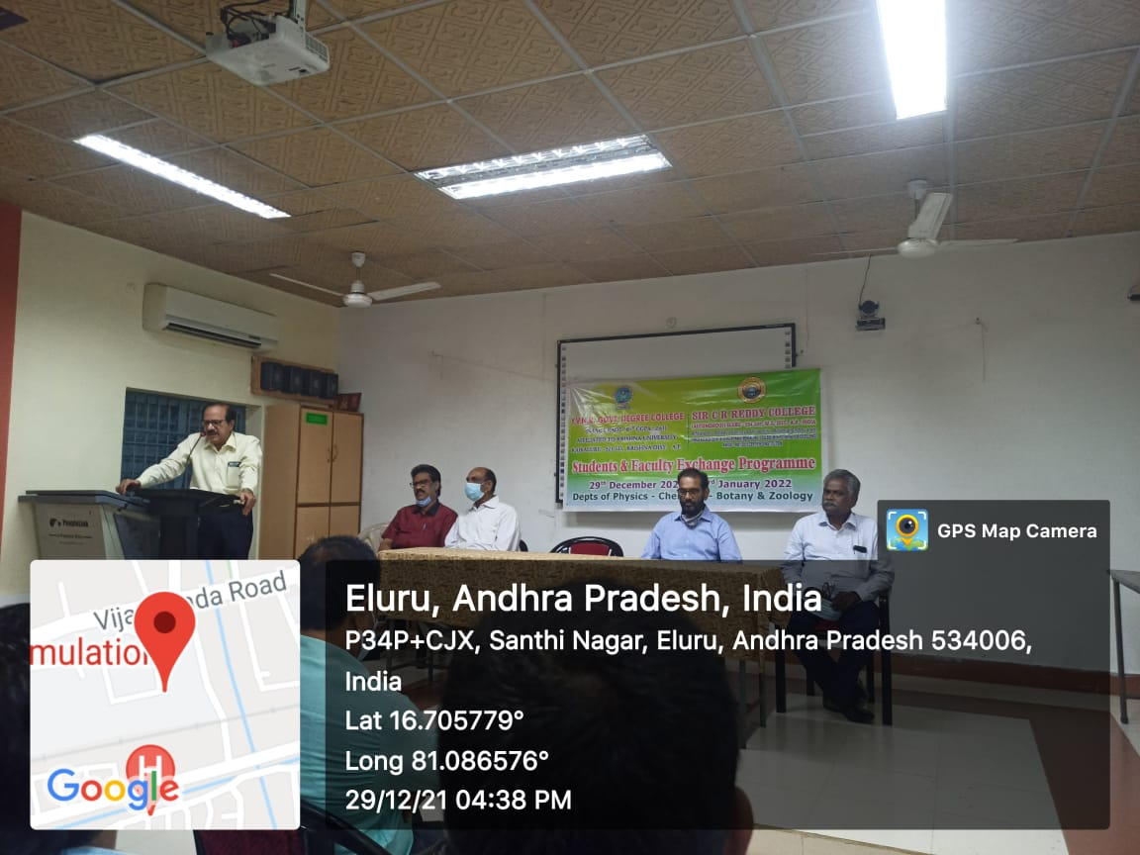

**Speech By Dr. K.A. Rama Raju, Principal, Sir C.R.Reddy College, Eluru**

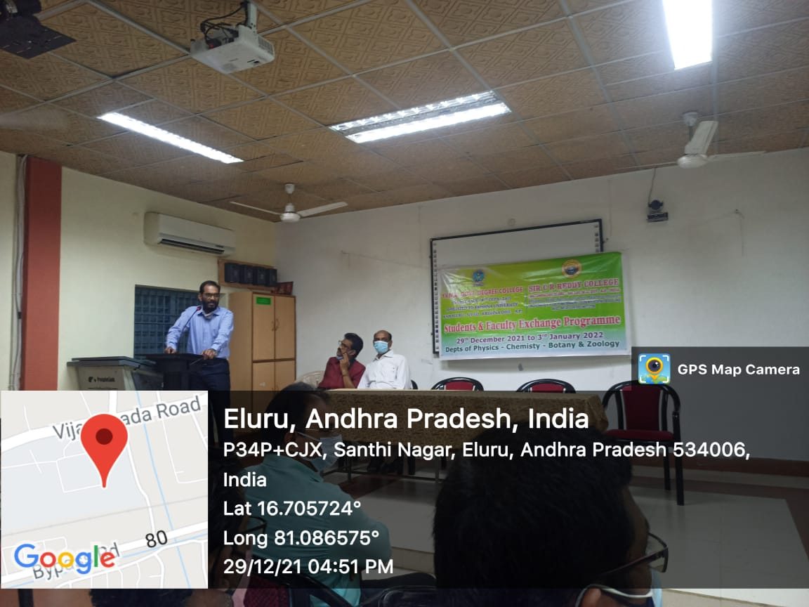

**Speech by Dr. K.S. Vishnu Mohan, M.S. (Ortho) Correspondent, Sir C.R.Reddy College, Eluru**

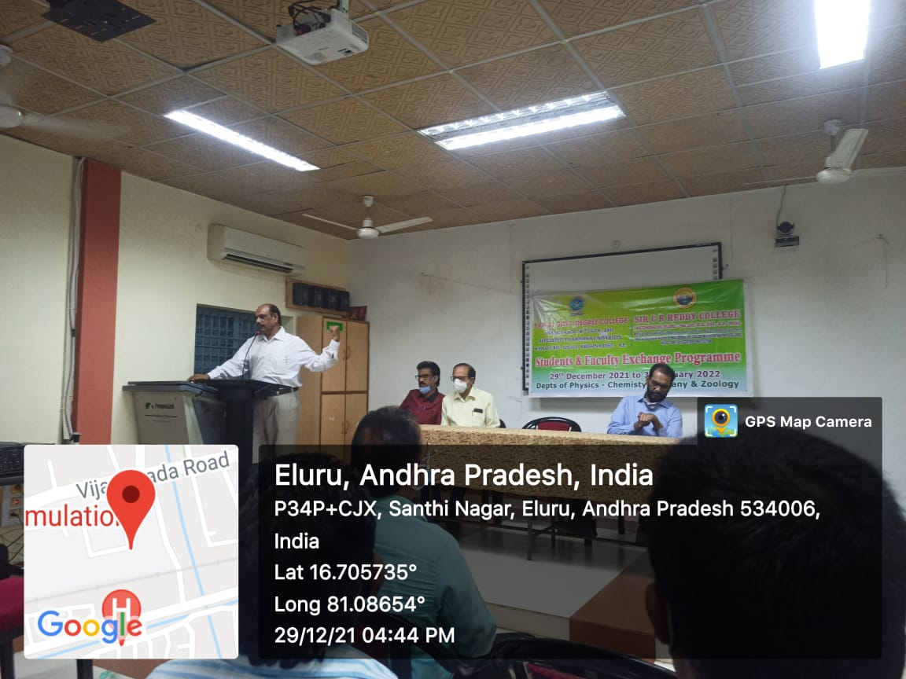

**Speech by Dr. M.S. SATYANARAYANA, NAAC ADVISOR, Sir C.R.Reddy College, Eluru**

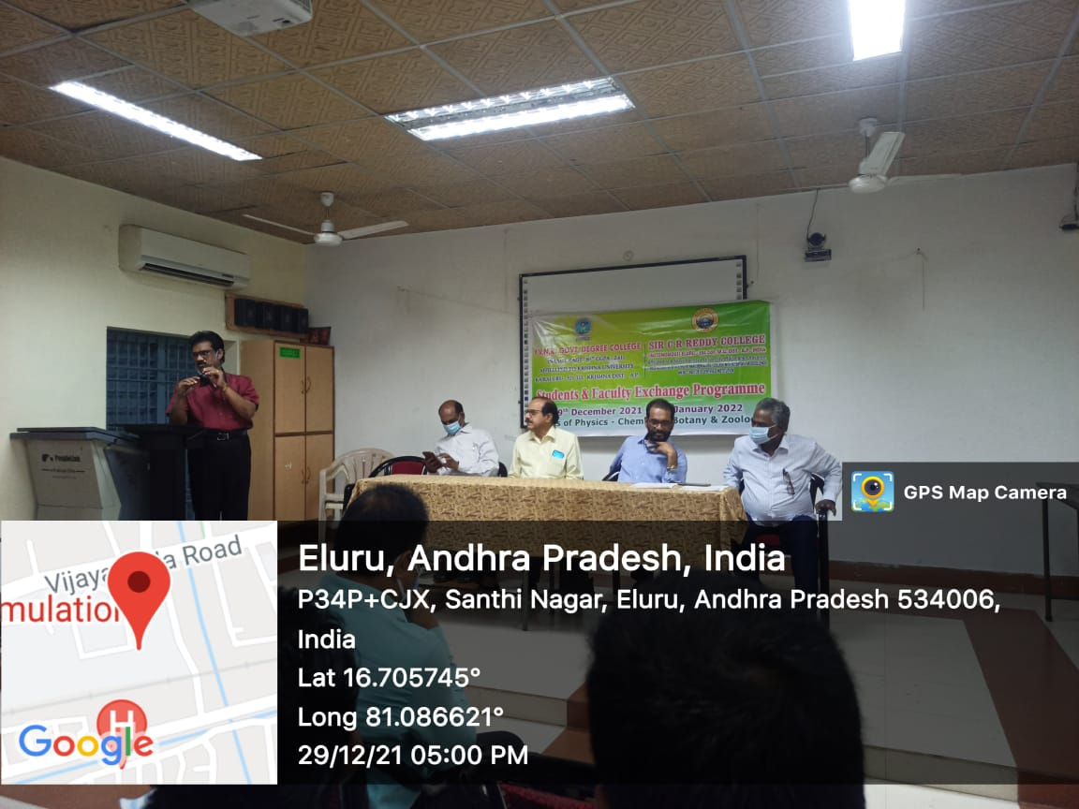

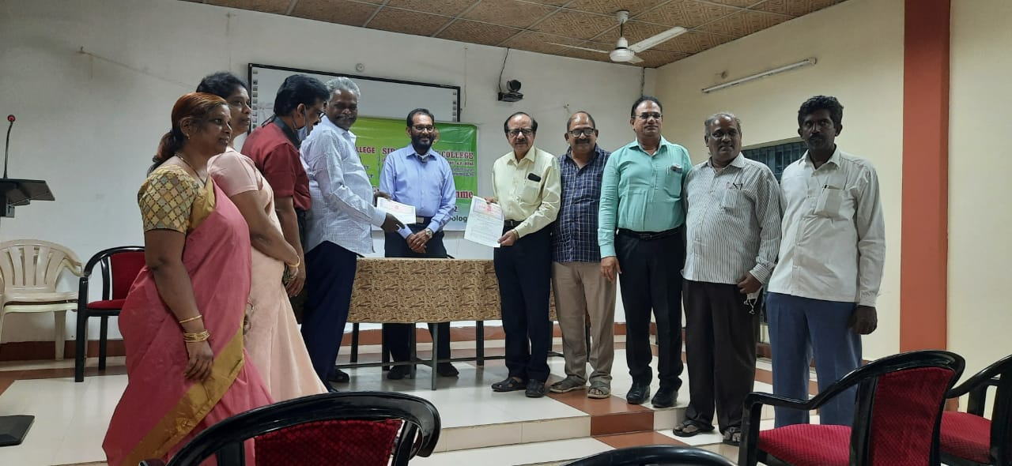

**YVNR Government DEGREE College,Kaikaluru Exchanging MoU with Principal, SIR C R REDDY AUTONOMOUS COLLEGE, ELURU in presence of Correspondent and management.**

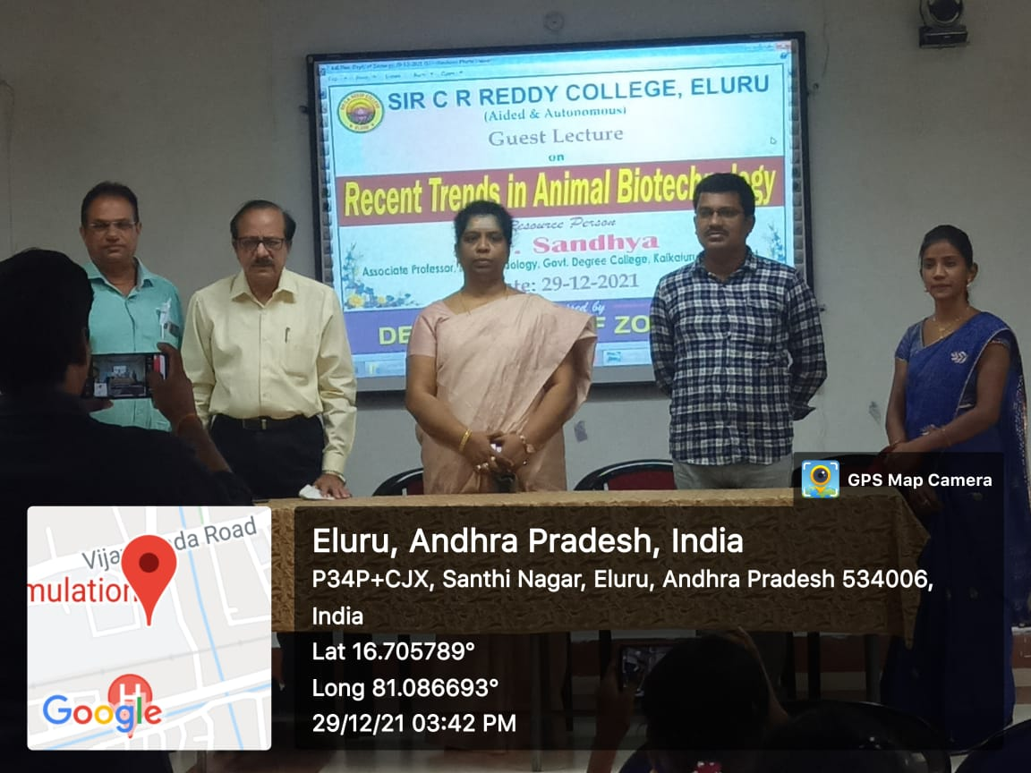

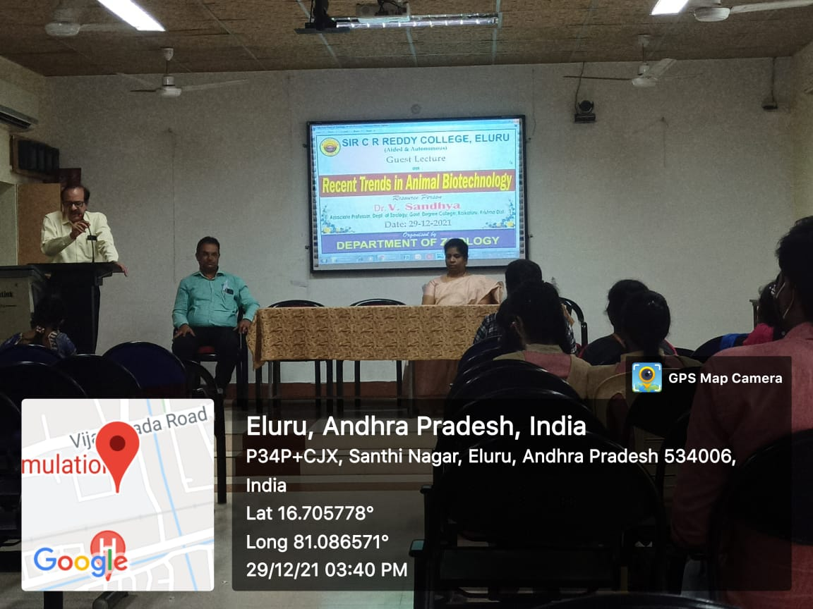

**Dr.V.Sandhya, Lecturer in-charge, Department of Zoology taking classes for**

**SIR C R REDDY AUTONOMOUS COLLEGE ZOOLOGY students**

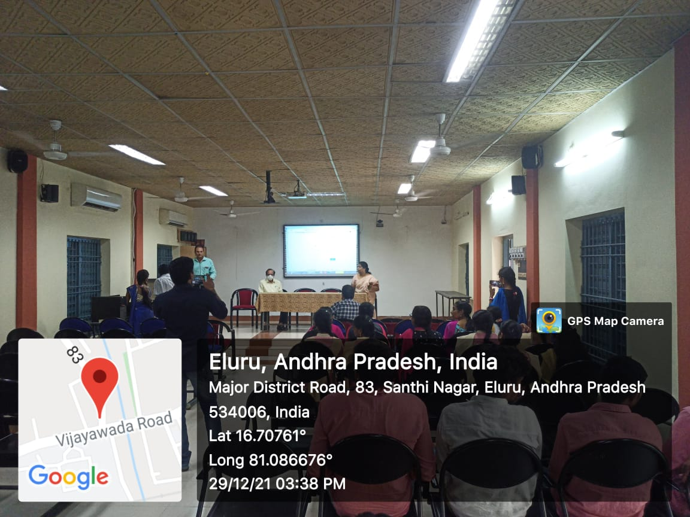

**Dr.V.Sandhya, Lecturer in-charge Department of Zoology taking classes for**

**SIR C R REDDY AUTONOMOUS COLLEGE students**

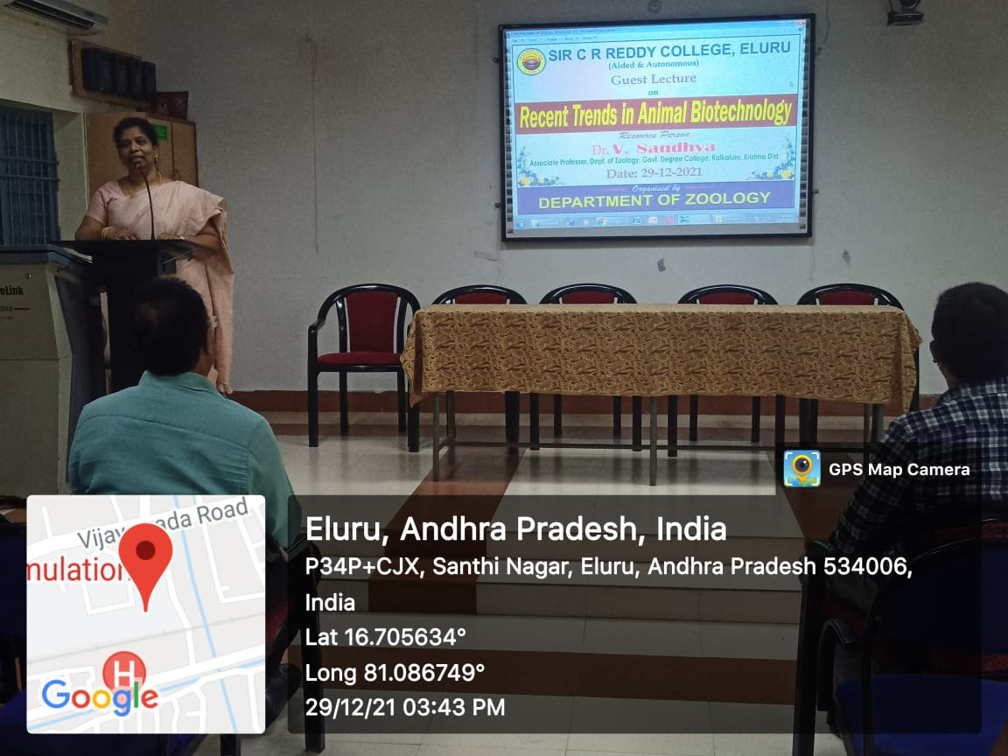

**Dr.V.Sandhya, Lecturer in-charge Department of Zoology taking classes for**

**SIR C R REDDY AUTONOMOUS COLLEGE students**

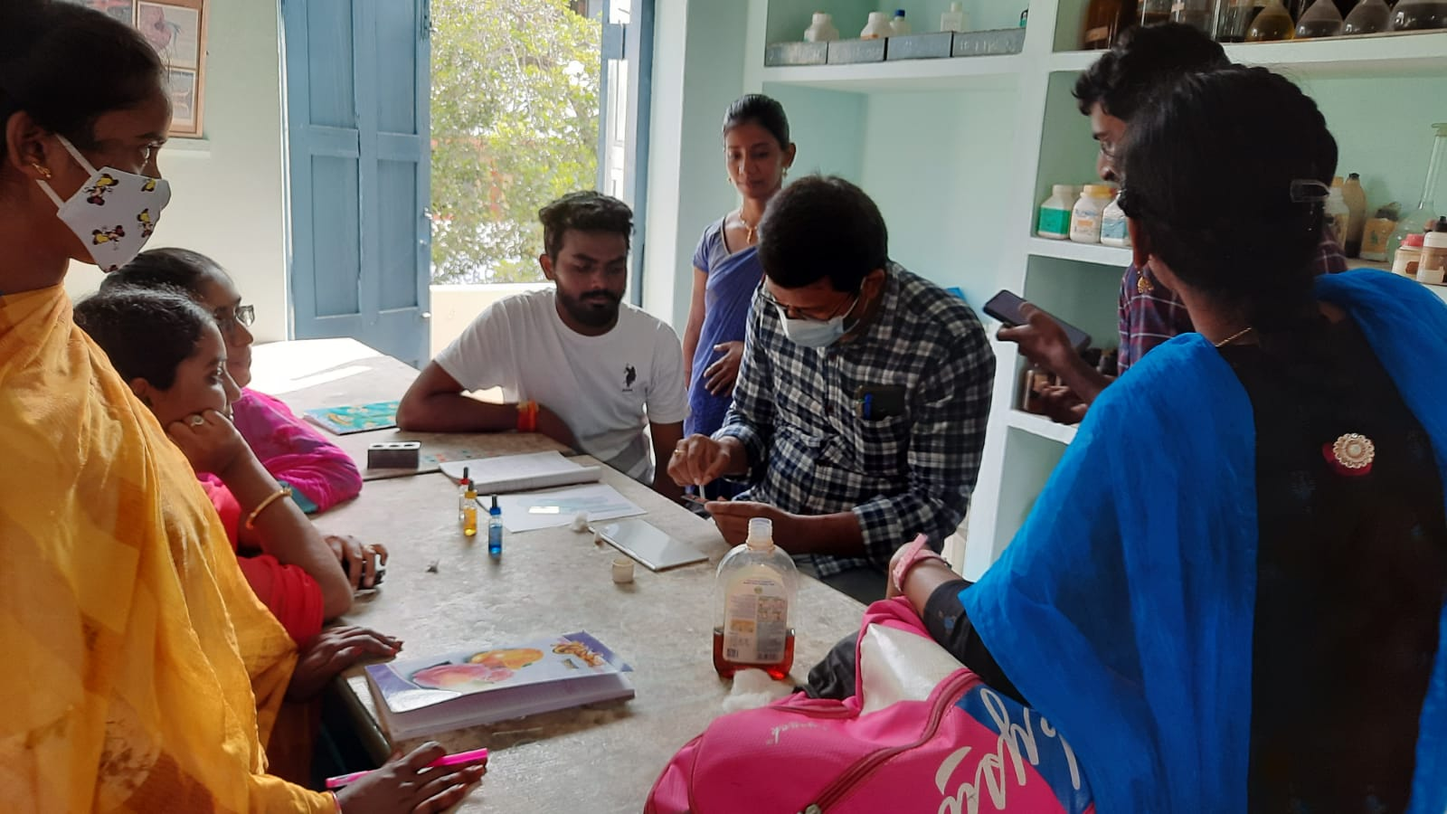

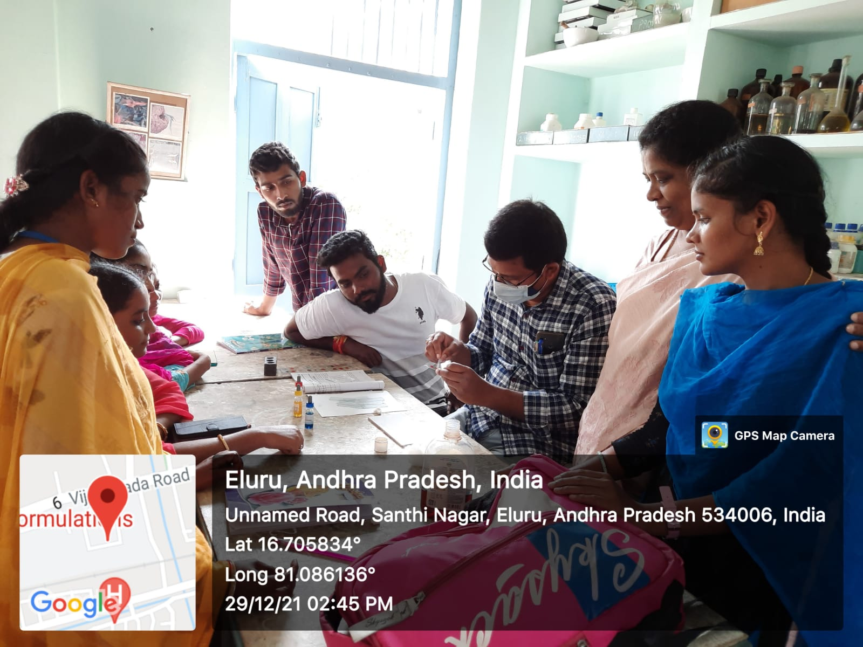**Lt. Mareedu Naveen Kumar, Lecturer in Zoology Sir C R Reddy College (A), Eluru, taking practical classes for students**

**Zoology museum is housed with an attractive central row of glass show cases surrounded by a neat carpet. Majority of the specimens are the collections made by the staff and students of the Zoology Department. A number of imported specimens like: Euplectella, Hyalonema, Phakelia, Chaetopterus, Basket Starfish, Lepidosiren, Protopterus, Amia, Lepidosteus, Acipencer Polypterus, Siren, Amphiuma, Poison-Arrow Frog, Phrynosoma Crotalus, European Viper, Japanese Snakes, Opossum and Kangaroo are only a few in the long list of rare specimens.**

**A number of beautifully framed charts showing the distribution of animals in various Zoogeographical regions is well displayed.**

**A number of articulated skeletons of different vertebrates are also arranged in glass show cases neatly. A good collection and beautiful display of postage stamps depicting various animals is an added attraction.**

**With so many exhibits the Museum is well represented in all branches and it is claimed as one of the best in Andhra Pradesh.**

**A number of charts are displayed depicting the physiological aspects of various systems.**

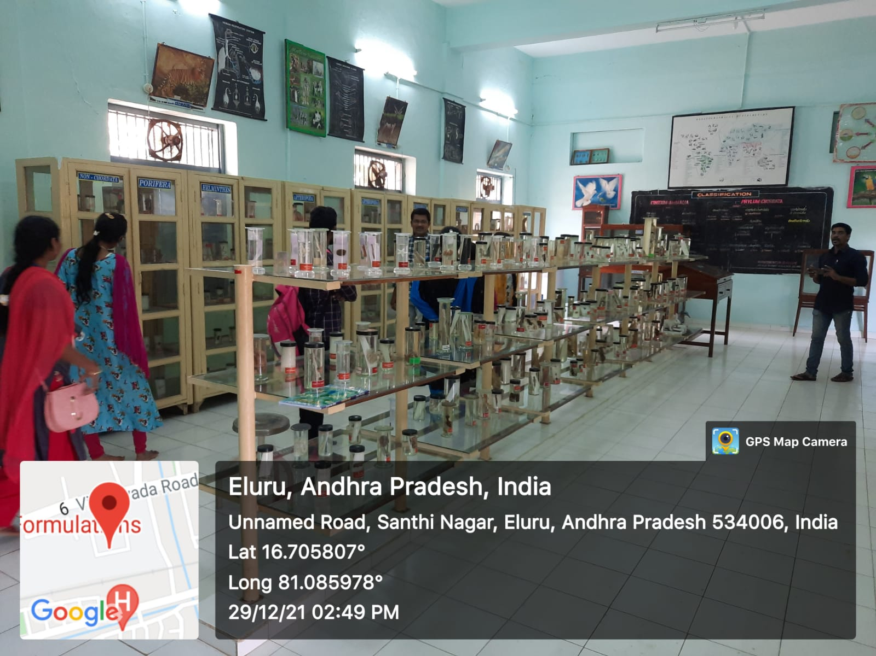

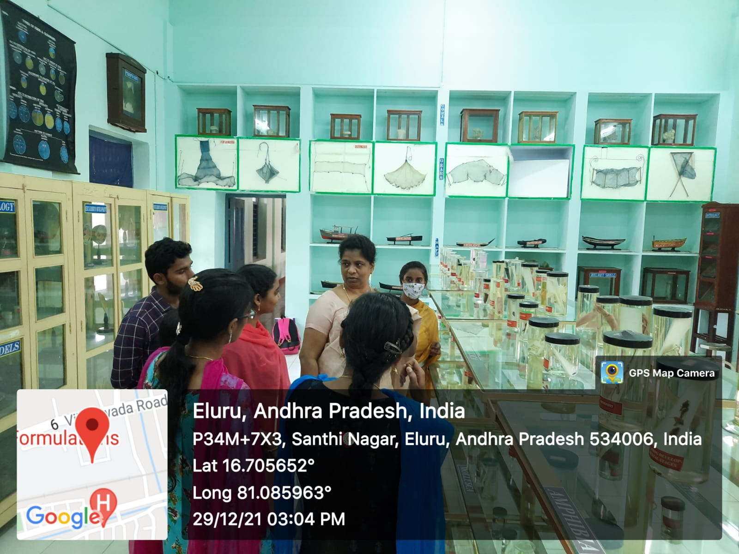

**Students Visit to the Zoology Museum Of SIR CR REDDY COLLEGE,ELURU**

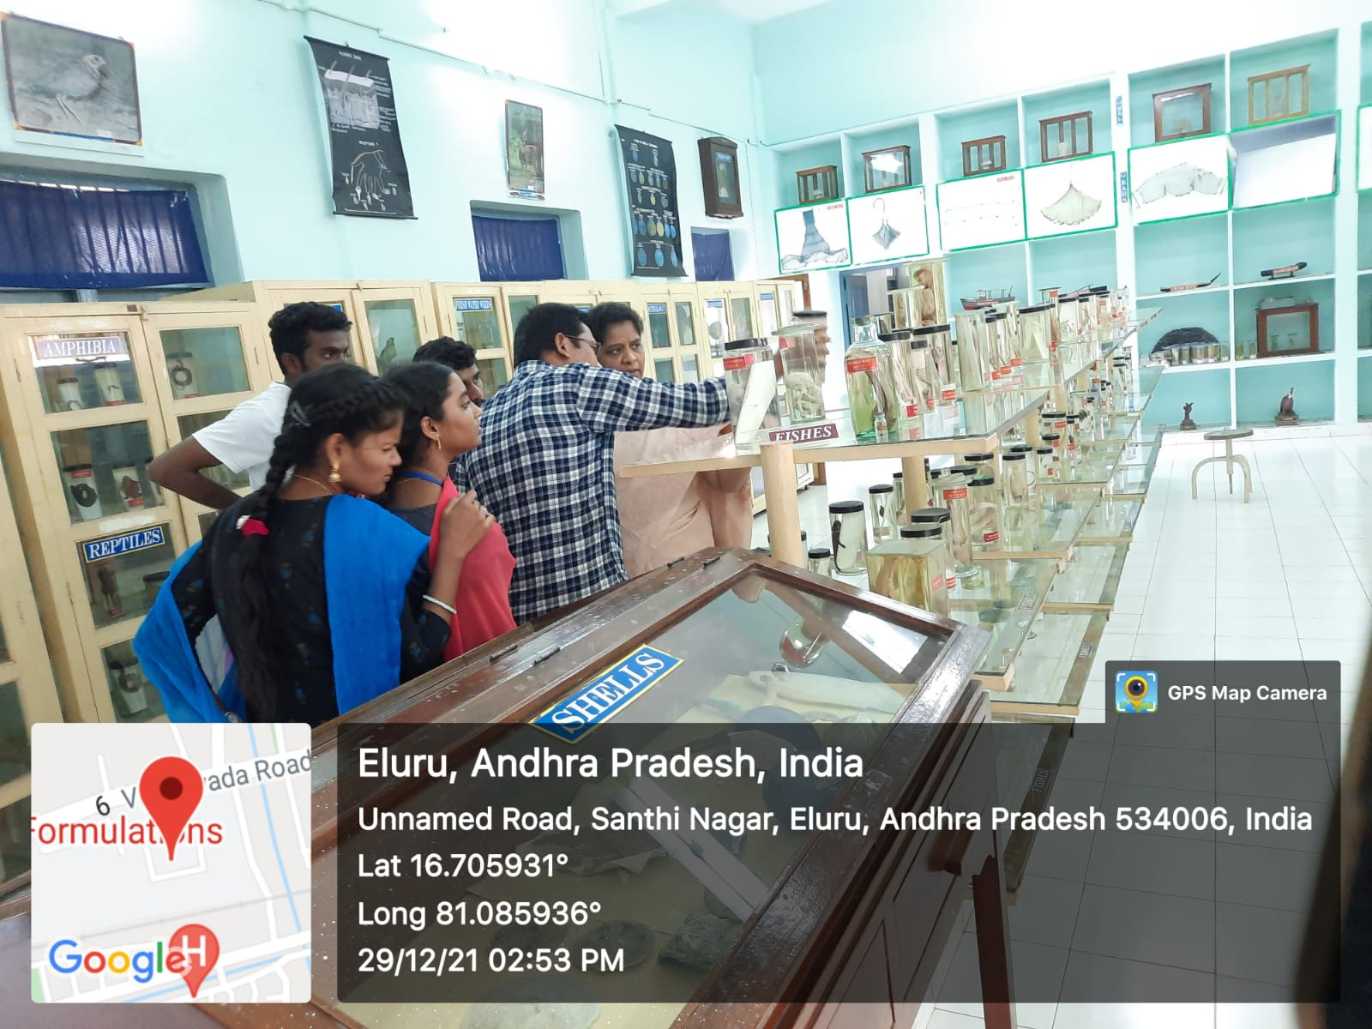

**Students Visit to the Zoology Museum**

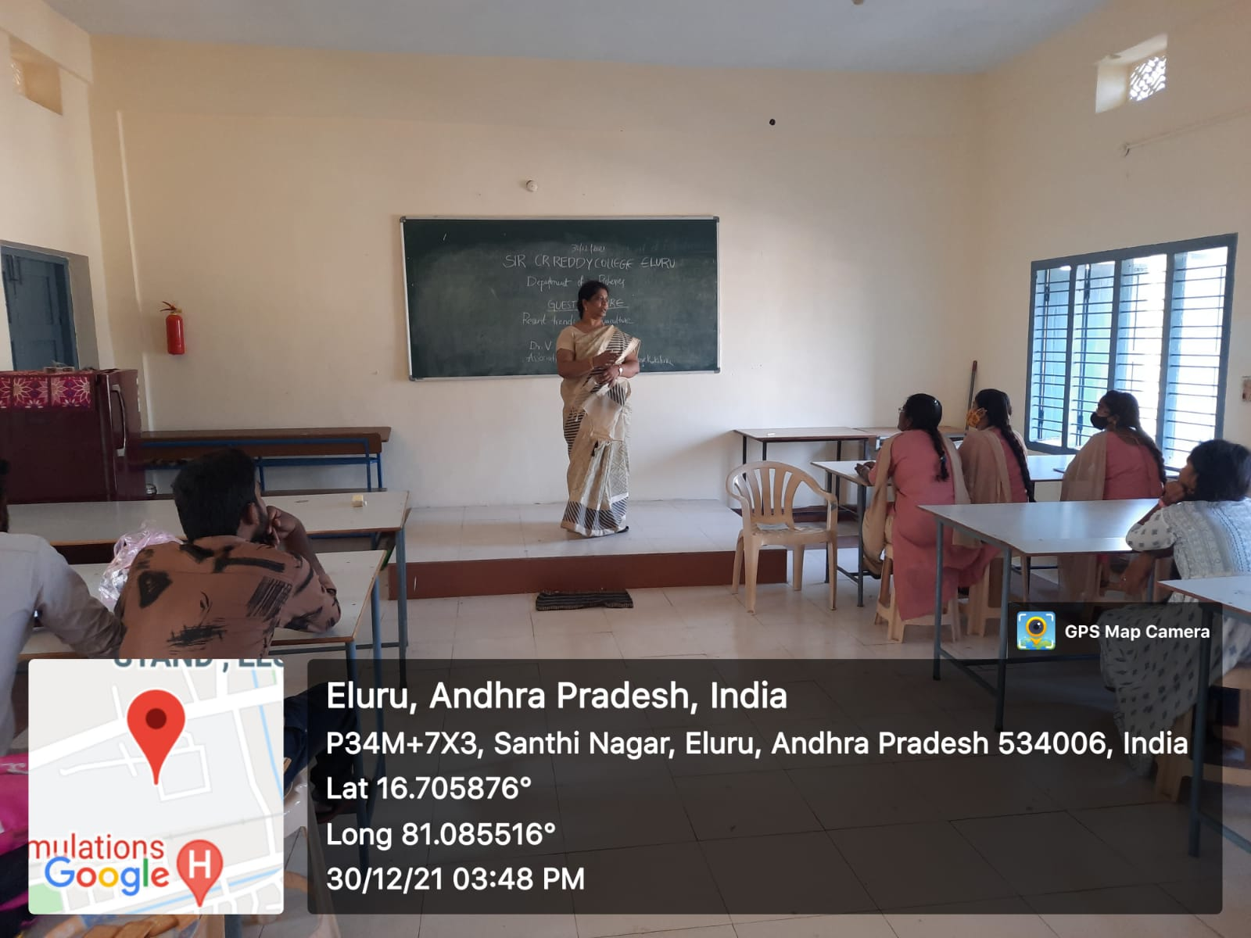

**Dr.V.Sandhya, Lecturer in-charge Department of Zoology taking classes for**

**SIR C R REDDY AUTONOMOUS COLLEGE students**

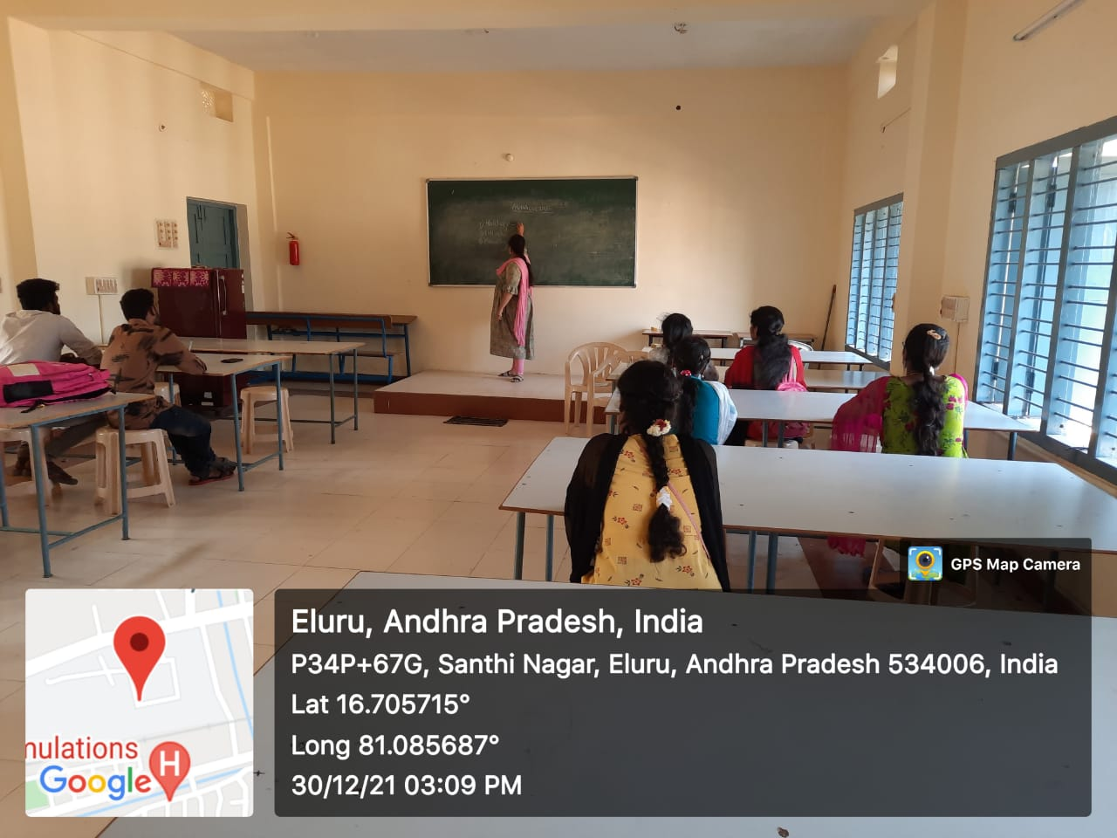

**Ms.SIRI, Lecturer in FISHERIES taking classes for YVNR COLLEGE BZC Students**

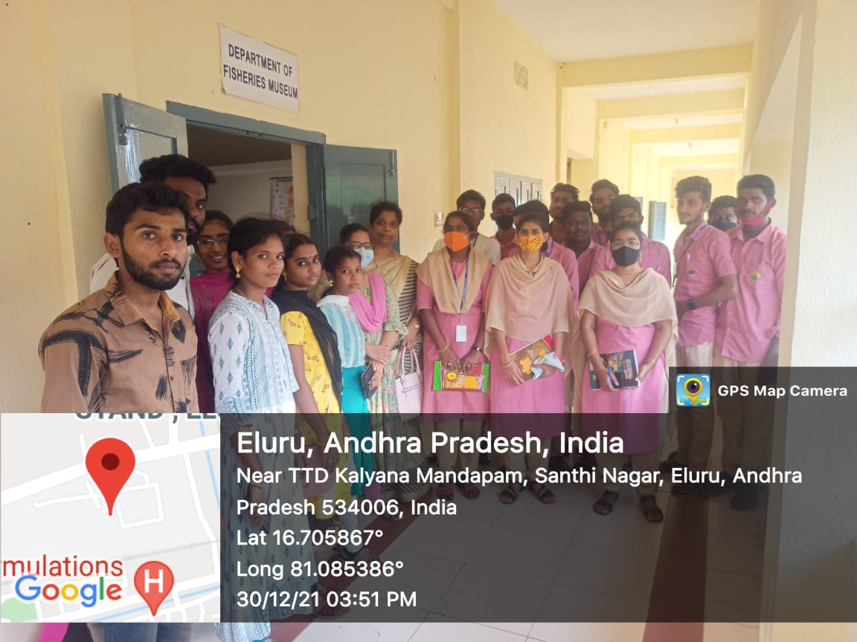

**VISIT TO FISHERIES DEPARTMENT**

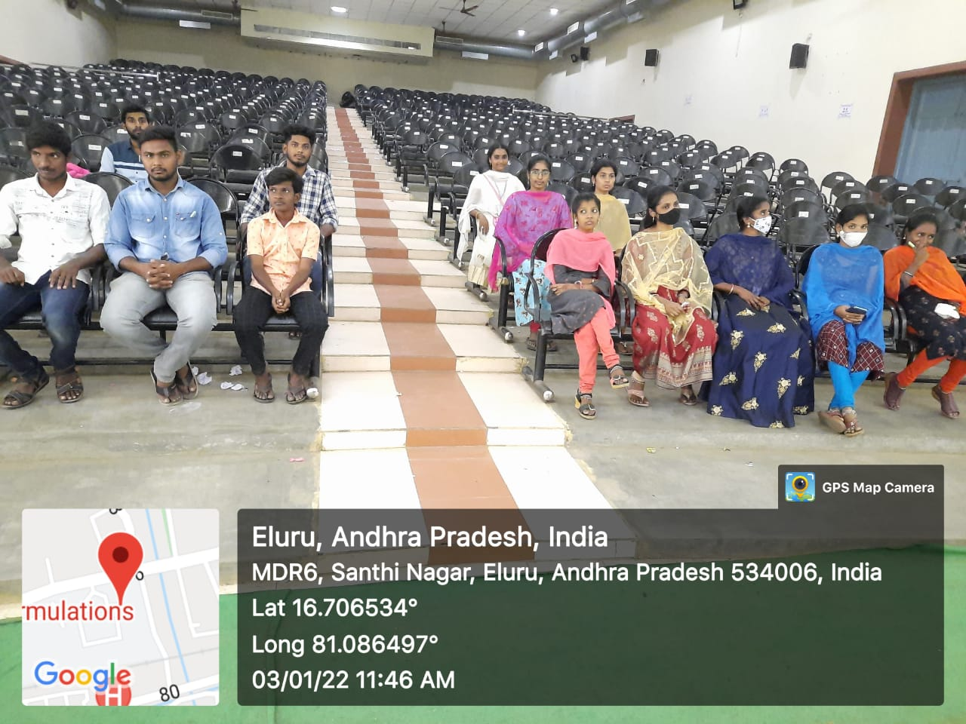

**VISIT TO AUDITORIUM**

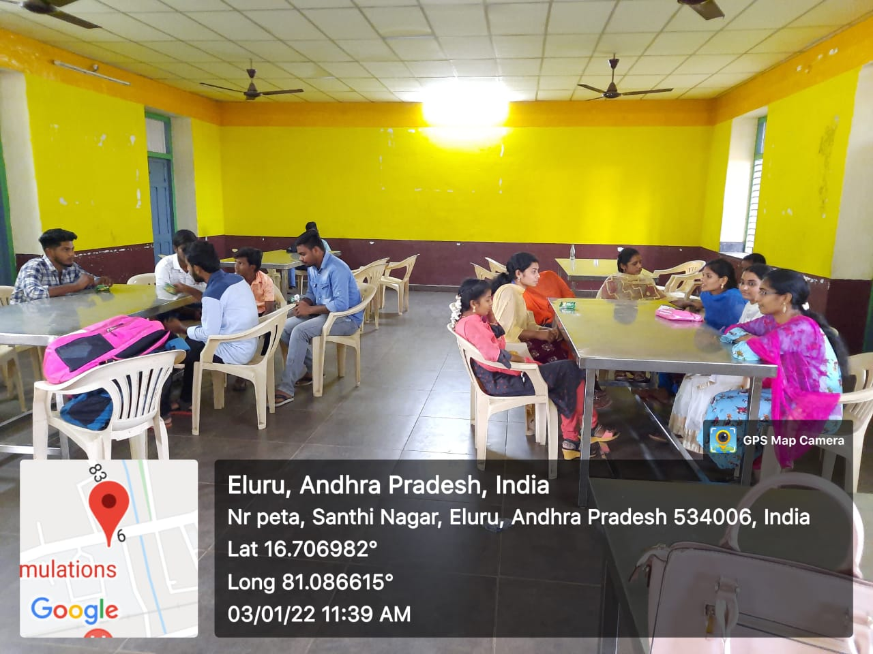

**VISIT TO CANTEEN**

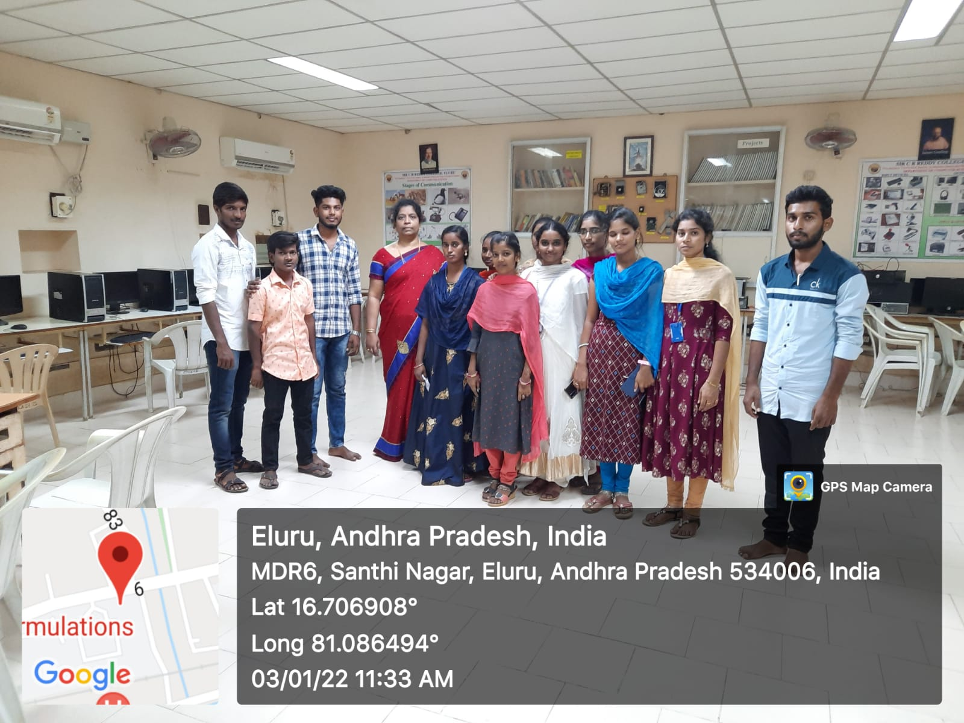

**VISIT TO COMPUER LAB**

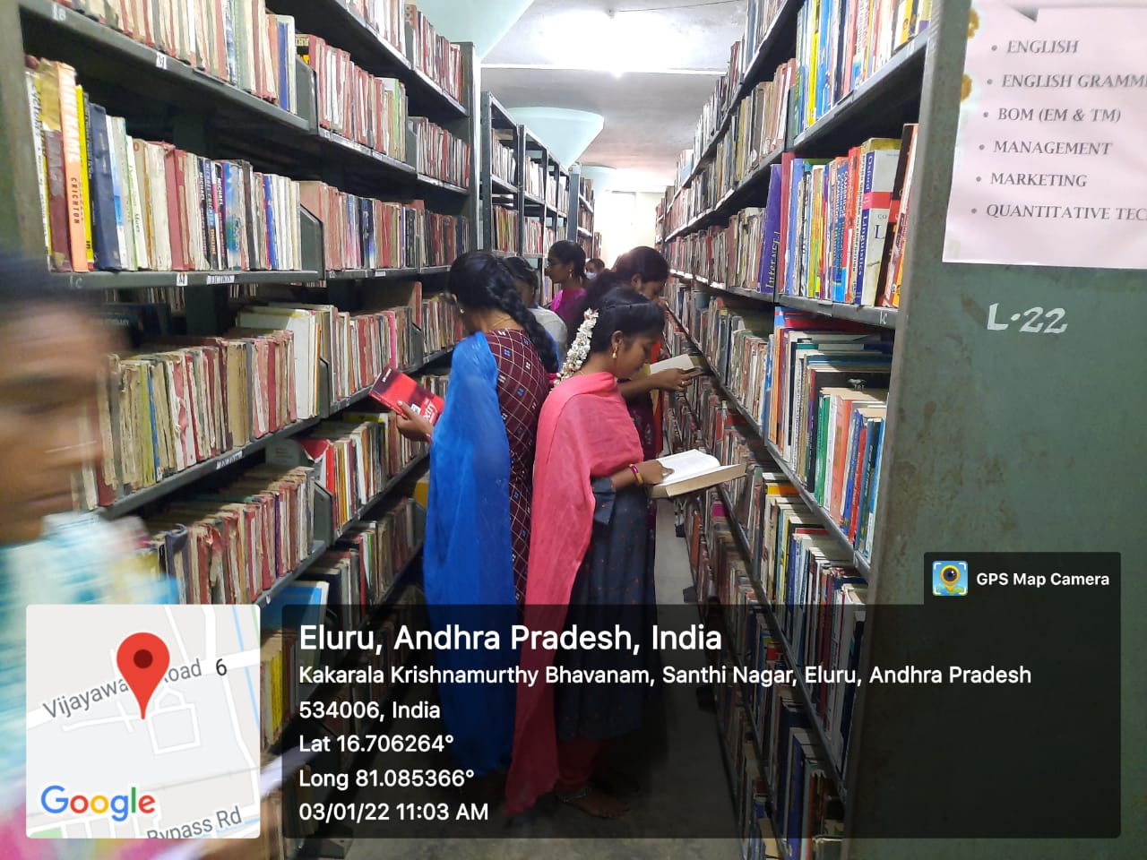

**VISIT TO LIBRARY**

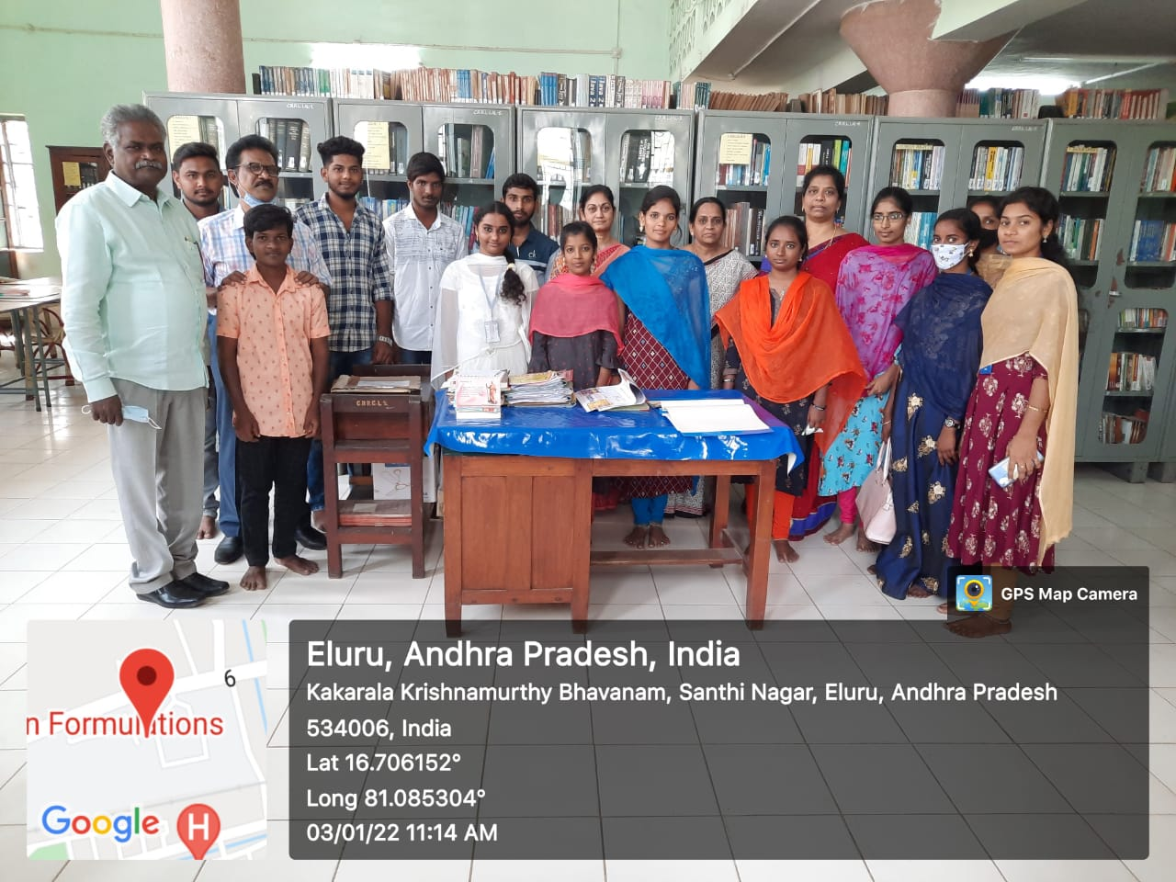

**VISIT TO LIBRARY**

***STUDENTS & FACULTY EXCHANGE PROGRAMME***

**29-12-2021 TO 03-01-2022.**

Programme sheet

## VALEDICTORY FUNCTION

|  |  |  |  |
| --- | --- | --- | --- |
| **S.No.** | **Time** | **Programme** | **Name of the person** |
| 01 | 03.00-03.05 | Invitation of Guests on to the Dias | Sri K. Visweswara Rao |
| 02 | 03.05-03.10 | Prayer | Students |
| 03 | 03.10-03.15 | Opening Remarks By President. | Dr. K. A. Rama Raju (Principal) |
| 04 | 03.15-03.20 | Valedictory Address by Correspondent | Dr. K. S. Vishnu Mohan  M.S (Ortho) |
| 05 | 03.20-03.25 | Speech | Dr. P. Paul Divakar |
| 06 | 03.25-03.30 | Speech | Dr. V. Sandhya |
| 07 | 03.30-03.35 | Response from Participants | Students |
| 09 | 03.35-03.40 | Vote of Thanks | Dr. K. A. Emmanuel |
|  |  | **NATIONAL ANTHEM** |  |

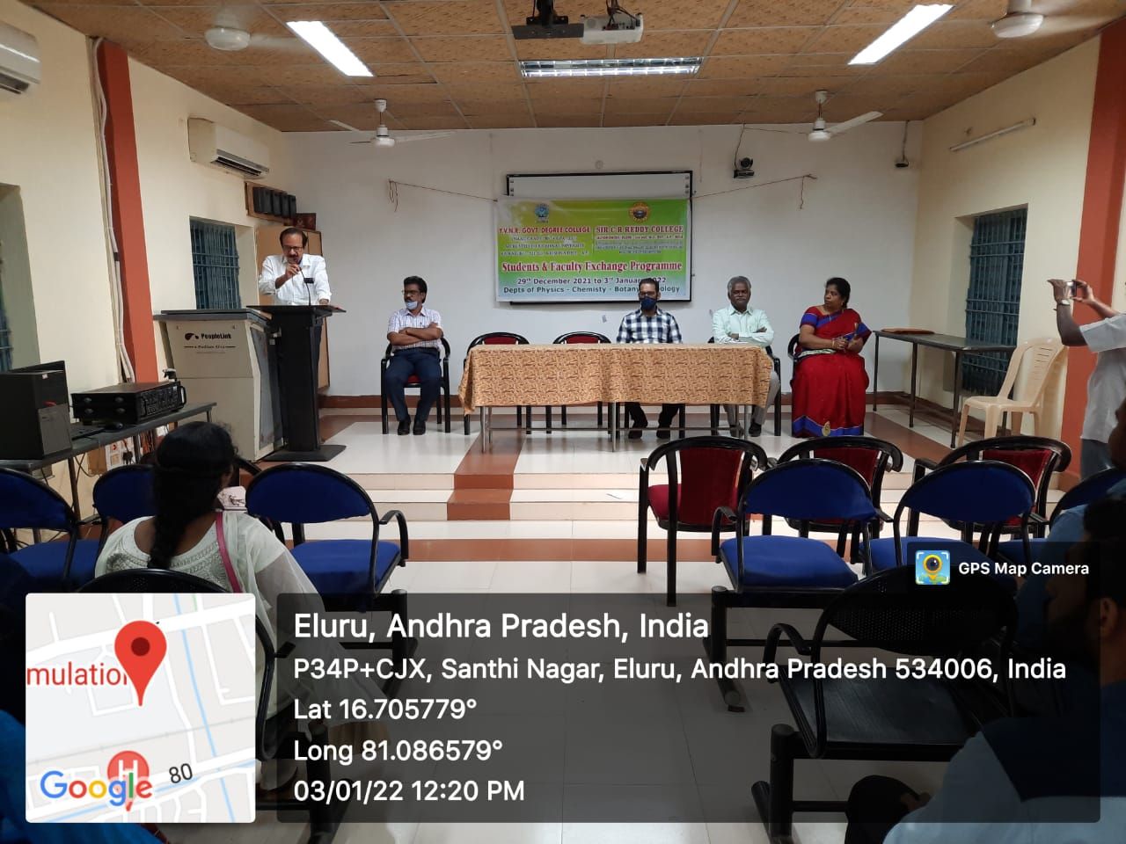

**Principal of SIR C R REDDY AUTONOMOUS COLLEGE, Dr. K A RAMA RAJU addressing the students of YVNR Government Degree College** **on the Valedictory function of Student Exchange Program.**

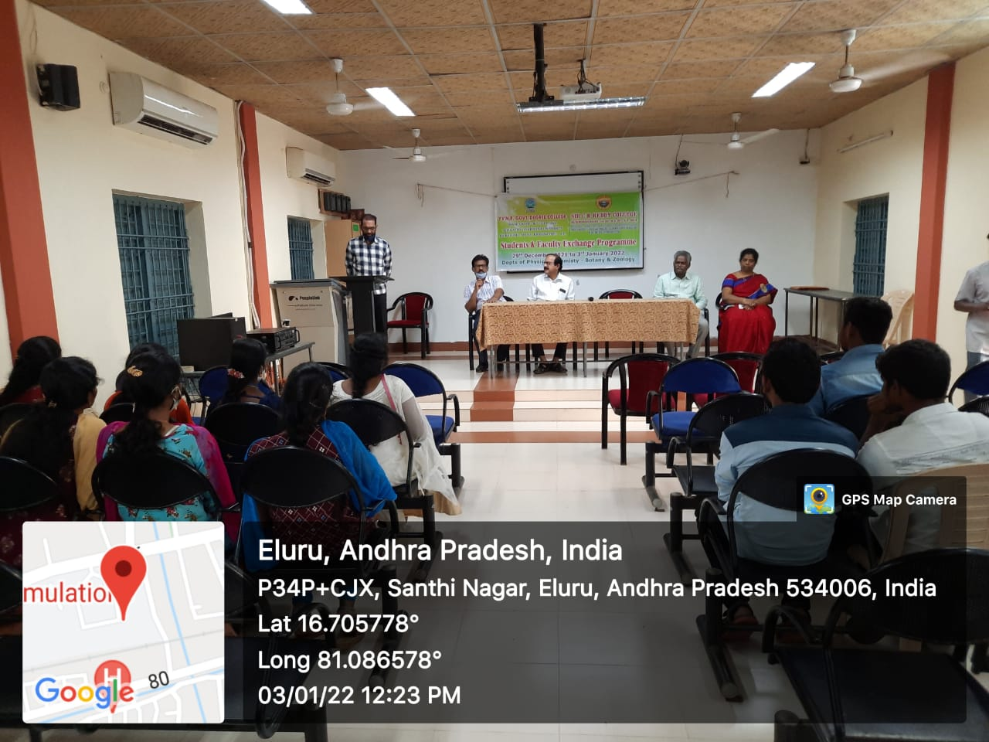

**Correspondent of SIR C R REDDY AUTONOMOUS COLLEGE, Dr.K.S.Vishnu Mohan addressing the students of YVNR Government Degree College on the Valedictory function of Student Exchange Program.**

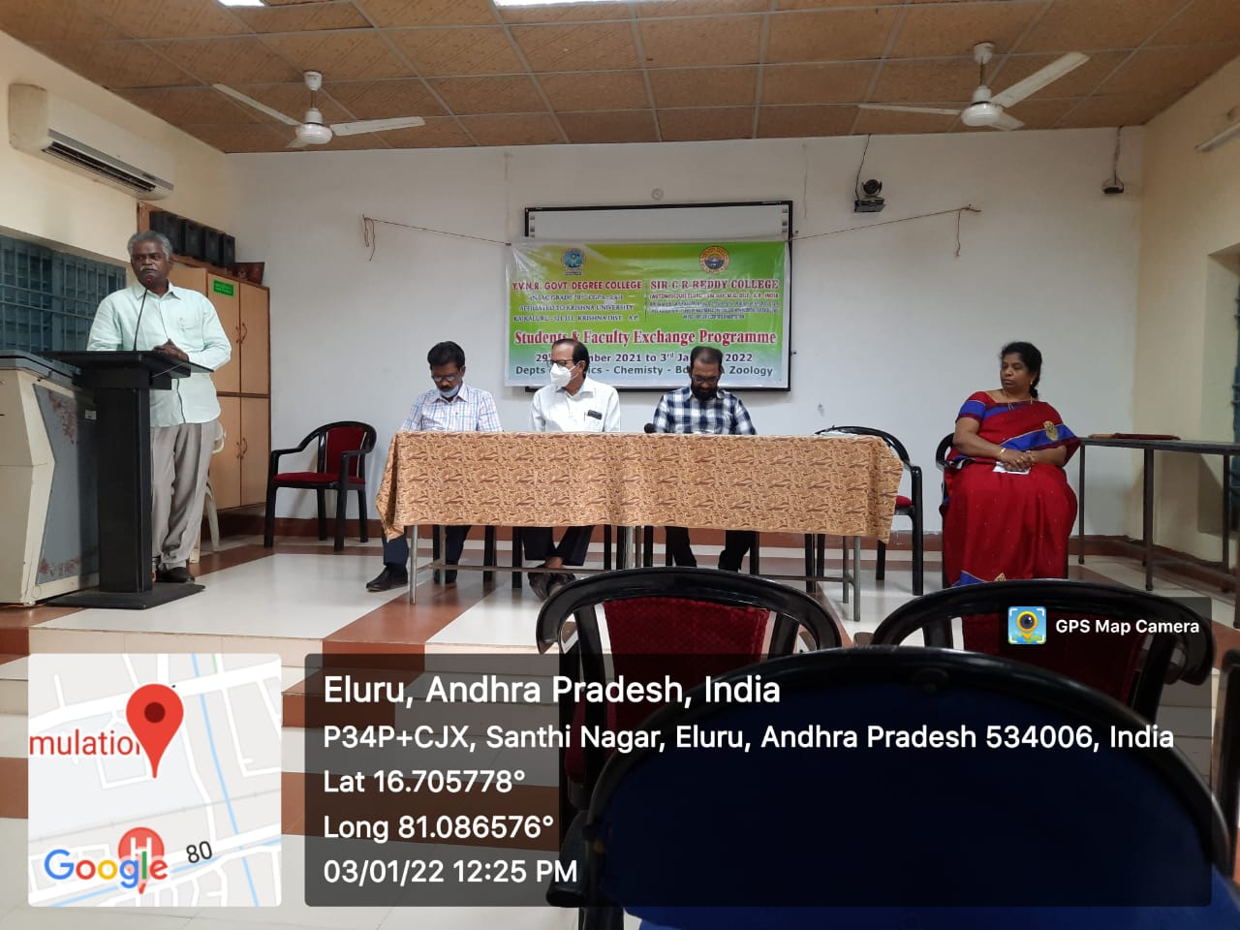

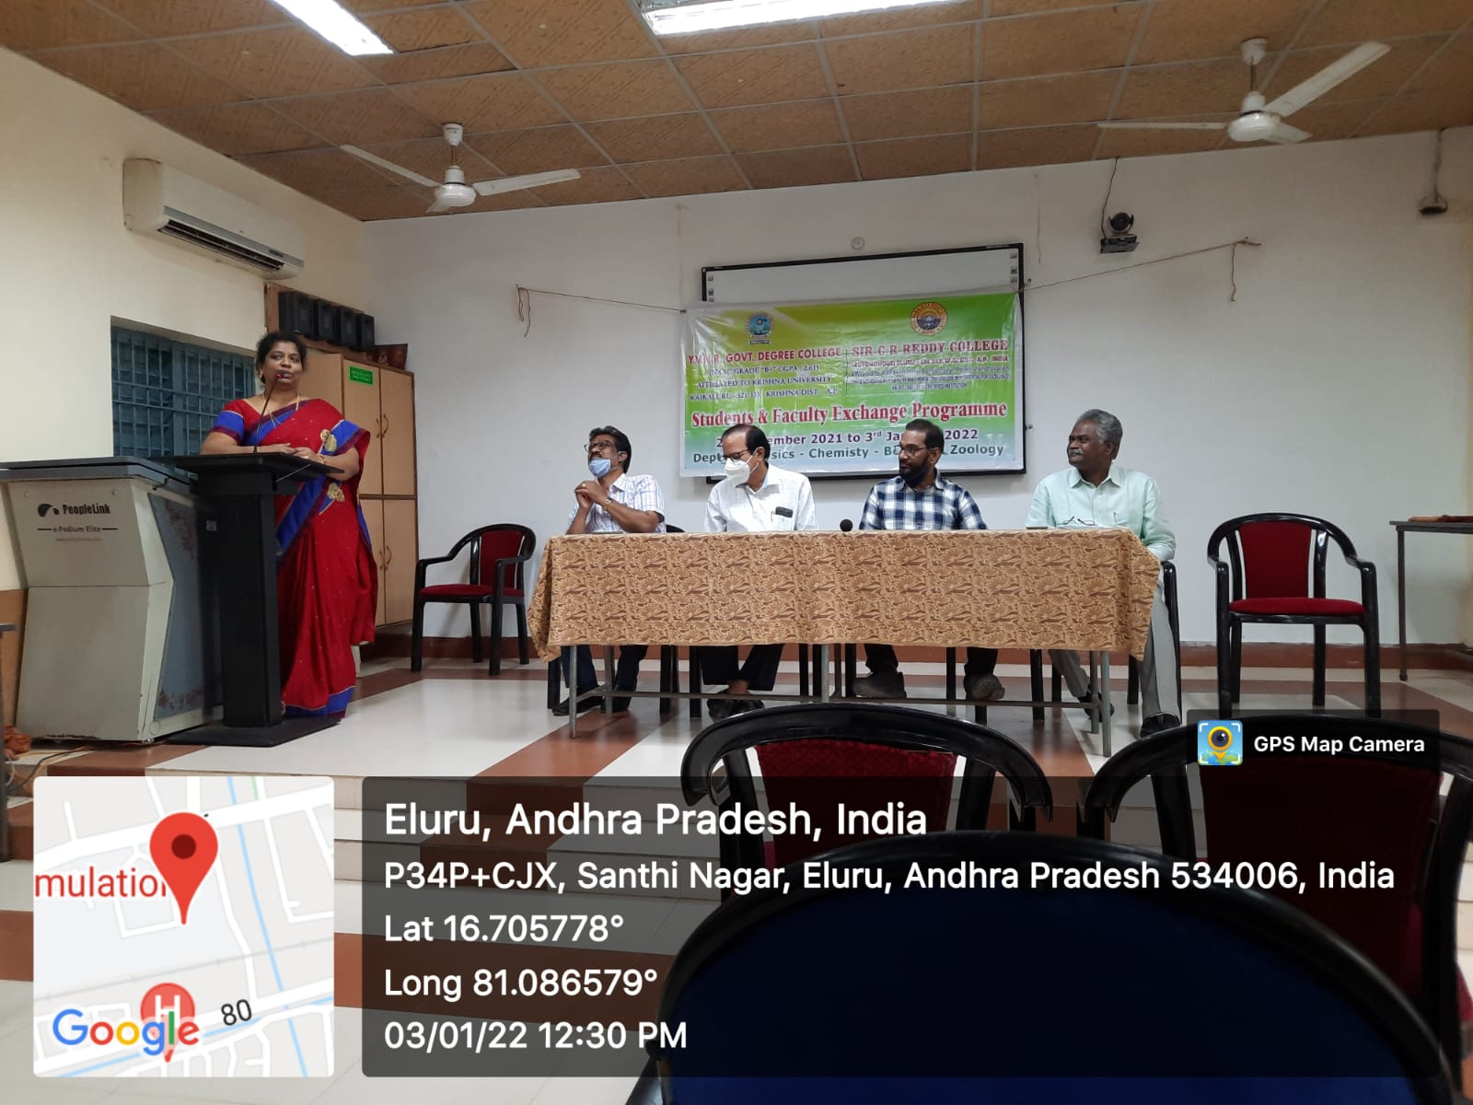

**YVNR GOVERNMENT DEGREE COLLEGE SATFF THANKING THE PRINCIPL AND MANAGEMENT OF SIR CR REDDY COLLEGE**

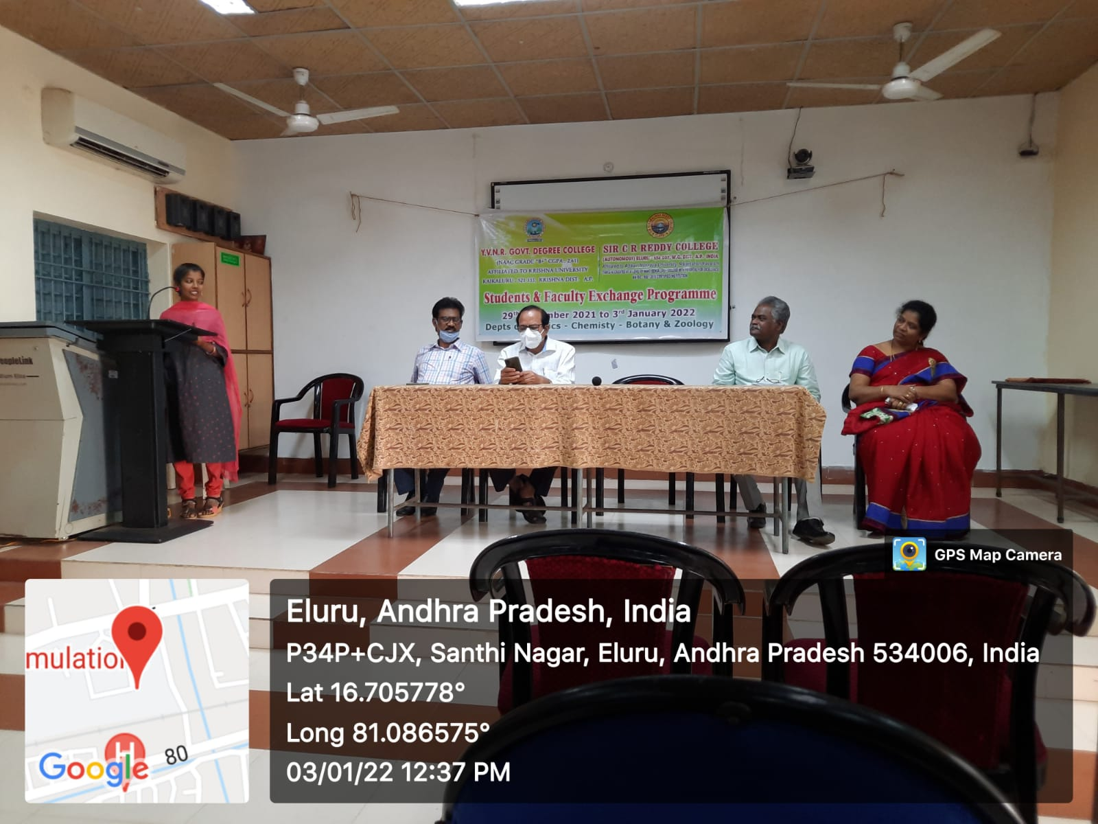

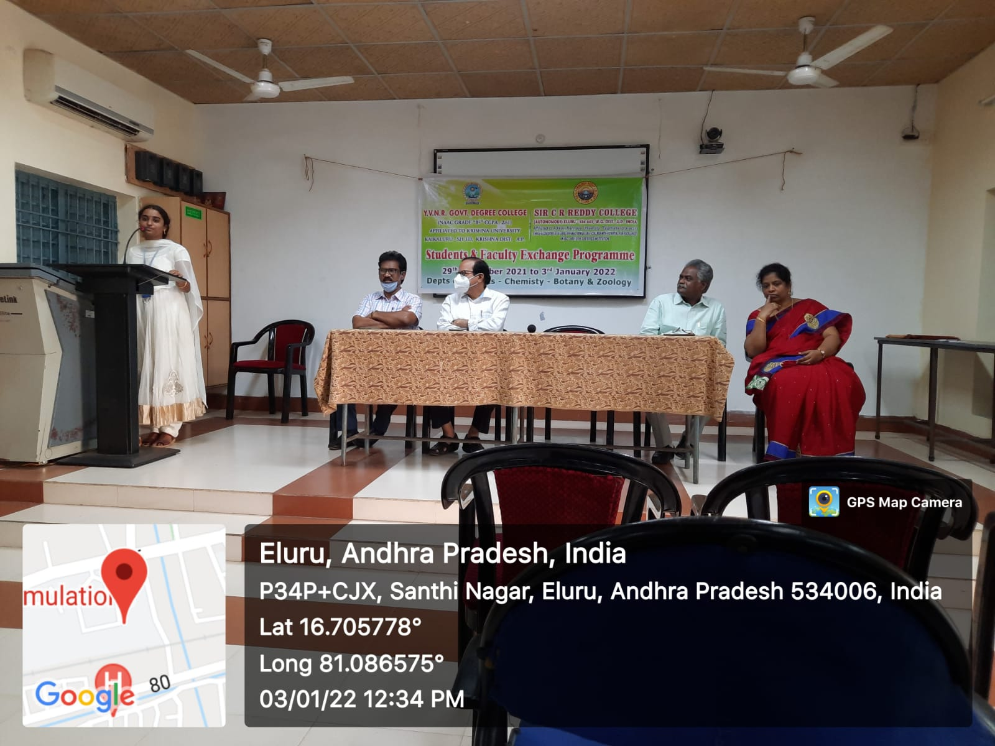

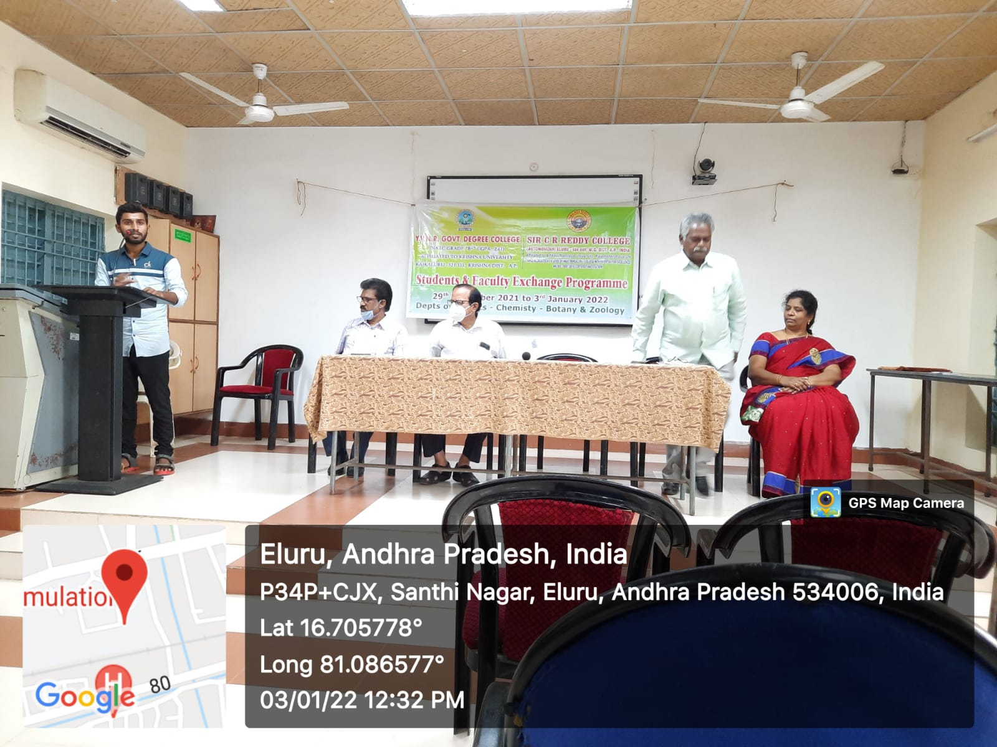

**Students from B.Sc. (BZC) Program of YVNR Government Degree College**

**giving feedback on the Student Faculty Exchange Program.**

# Y V N R GOVT. DEGREE COLLEGE

**KAIKALURU, Krishna District. NAAC B+**

*Affiliated to Krishna University, Machilipatnam, Krishna District*

**&**

# SIR C R REDDY COLLEGE

**(AUTONOMOUS) ELURU, W.G.DT**

*Affiliated to Adikavi Nannaya University, Rajamahendravaram*

**(Thrice accredited at level-A by NAAC, Bengaluru & College with Potential for Excellence) An ISO-9001: 2015 Certified Institution**

**DEPARTMENT OF ZOOLOGY**

**FACULTY & STUDENT EXCHANGE PROGRAMME**

**From 29-12-2021 to 03-01-2022**

|  |  |  |  |
| --- | --- | --- | --- |
| **S.No** | **Roll.no.** | **Name of the Student** | **Signature** |
|  |  |  |  |
|  |  |  |  |
|  |  |  |  |
|  |  |  |  |
|  |  |  |  |
|  |  |  |  |
|  |  |  |  |
|  |  |  |  |
|  |  |  |  |
|  |  |  |  |
|  |  |  |  |
|  |  |  |  |